# Building Engines

# *June 2018 Release Notes*

**What’s New?**

**Store Sales Reporting**

* For retail Property Managers, you can now leverage Building Engines for Store Sales Reporting
* Tenant Employees can submit sales monthly via the tenant portal for all their stores, across multiple locations

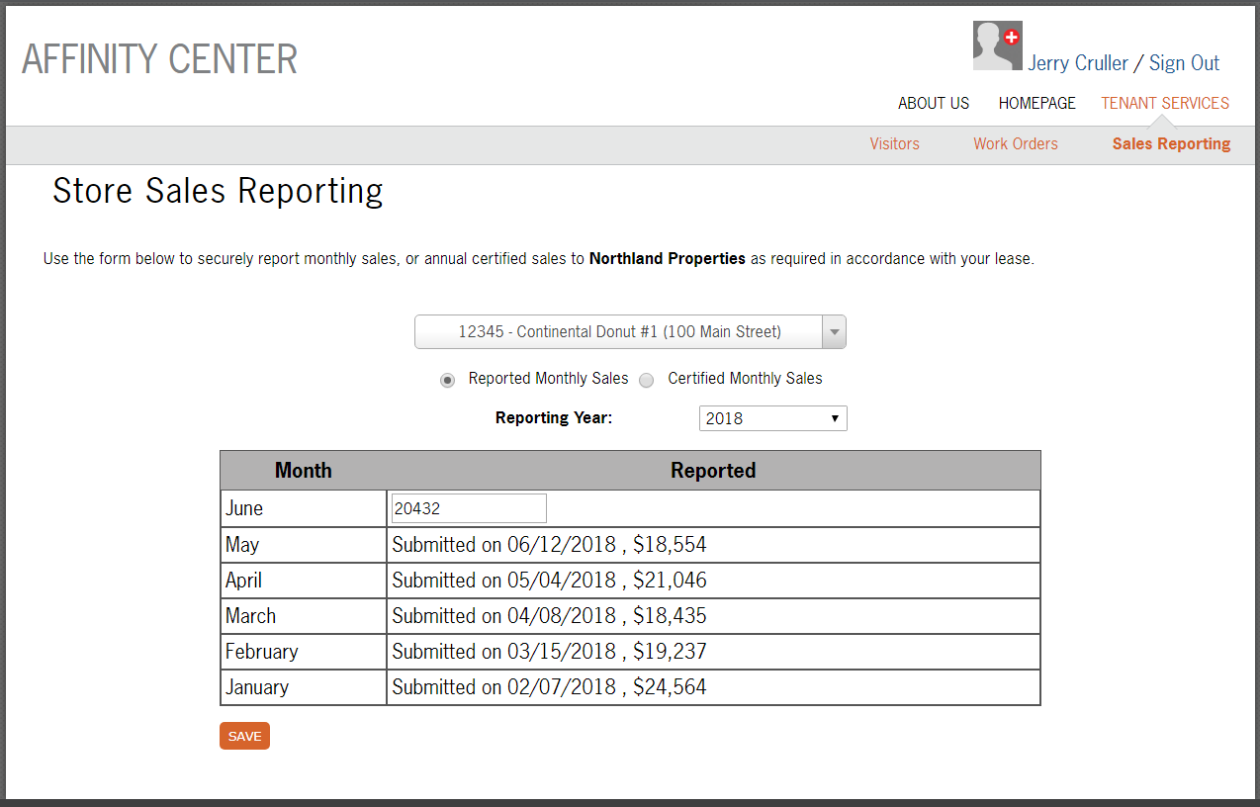

* Schedule your Tenant Store Sales Report on the frequency of your choice – delivered via email or fax
* Contact your Client Success Manager to learn more about configuration options

**Building Engines Wants to Know What You Think!**

* We will occasionally ask you to let us know how likely you are to recommend us to other colleagues in your industry
* Ensure that we are offering a quality product, that helps you achieve your day-to-day tasks efficiently & effectively

**Updates You’ve Been Looking Forward To**

**New Mobile Carriers Supported**

* We now support mobile text messaging for Tracfone, Straight Talk, Cricket Wireless, and Google Project Fi