# Building Engines

# *September 2018 Release Notes*

**What’s New?**

**Employee Hours**

* Building Engines now allows for more flexible employee hours, configurable on the employee profile page
  + Hours were previously limited to a single block of time per day
  + “Suppress notifications during non-work hours” still functions the same

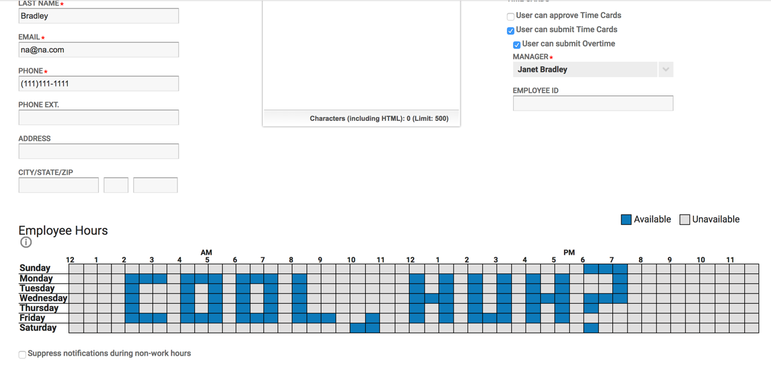

* This is in preparation of offering Shift-Based Assignment in Building Engines

**Impairment Notifications**

* Impairment notifications have been updated to include the restored date & time when applicable

**Updates You’ve Been Looking Forward To**

**Work Order Comments Included in Notifications**

* Upon Completion of a Work Order, any comments added will be included within the “Messages” portion of email notifications
  + This includes comments on labor hours
* This update is restoring functionality that previously existed

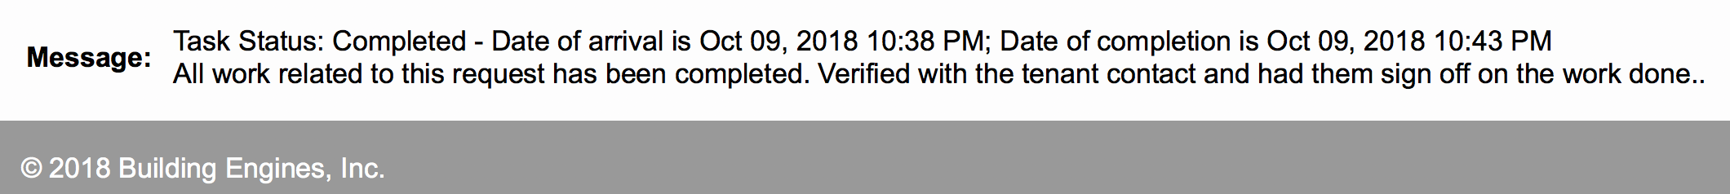

**Inspection Template Edits**

* Save feature within Inspection Templates was not always resulting in a question edit being saved, this has been resolved

**Additional Updates**

**BE Mobile Release Coming Soon**

* Building Engines has been made aware of BE Mobile performance issues that are impacting a handful of our clients – investigating these reports has been a focus for our team throughout August & September
  + Resolution to many of these issues will be included in our BE Mobile release, scheduled for the week of 10/8/18 – updates on our mobile release will be out shortly!
  + Reach out to our support team, or your Client Success Manager, if you’ve been impacted by this and want to learn more

**Custom Batch Files**

* Supporting accounting requirements for clients through custom batch files