# Building Engines

# *October 2018 Release Notes*

**What’s New?**

**Shift-Based Assignment**

* We updated our Employee Hours within the Employee Profile page last month, in anticipation of our new Shift-Based Assignment workflow
* Within *Admin 🡪 Notifications* you can now configure notifications to make auto-assignment decisions based on employee shifts

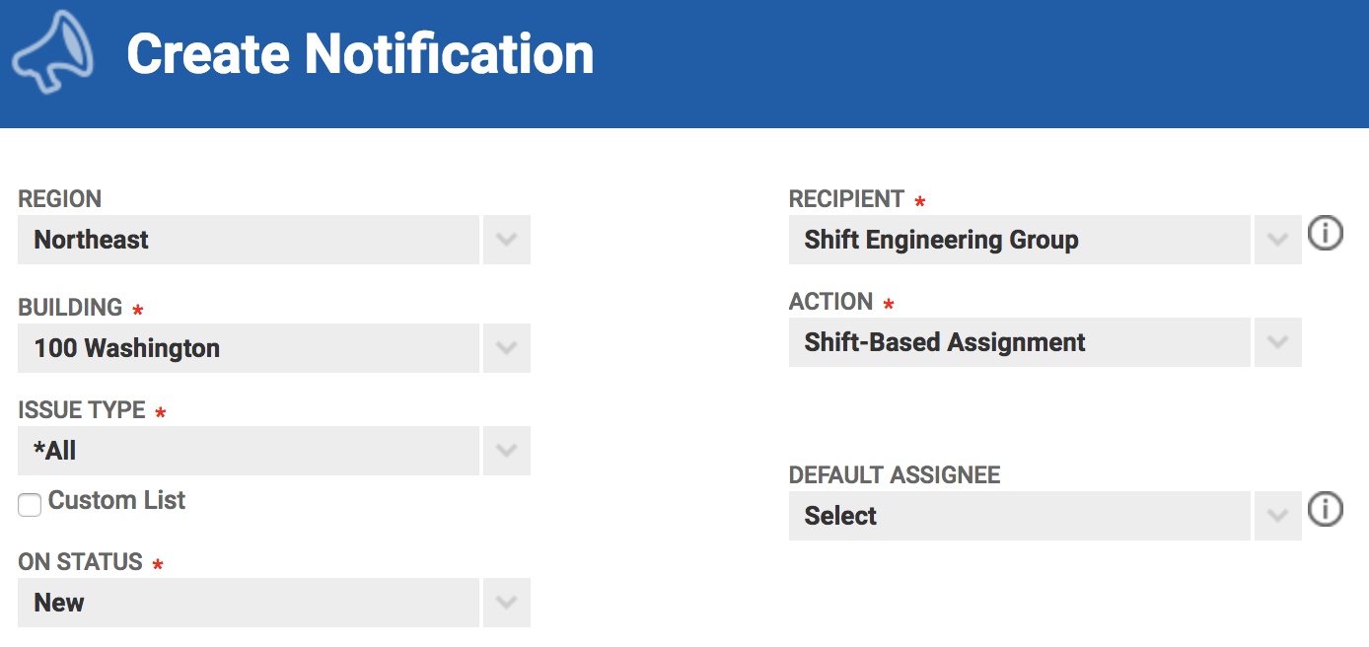

* This configuration requires that the recipient be a group (contact Support to configure a new group)
* This notification rule can only be applied to NEW Work Orders that are entered
* A Default Assignee is available to select and will be applied based on the workflow logic outlined below: 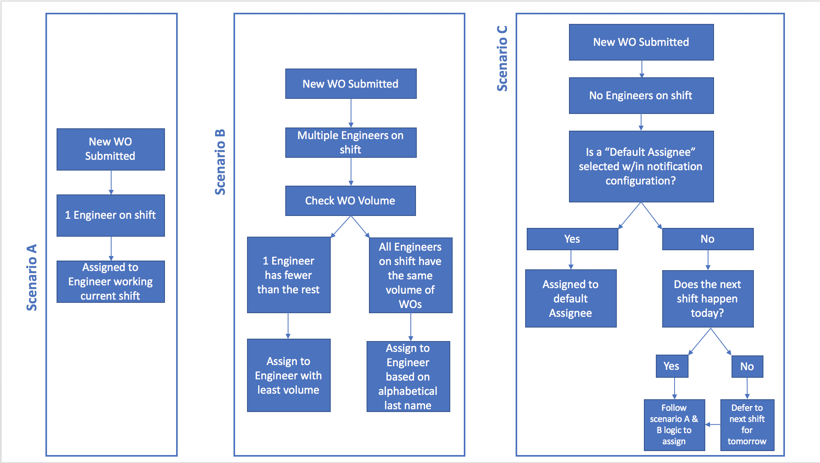

**Updated Upcoming COI Expiration Report**

* This report now includes COI Coverage Type breakdown
* Allows visibility into which coverage component is expiring

**Purchase Order Dashboard**

* Exposed additional columns when viewing PO information

**Mobile Release**

**Mobile 3.12 Available in Stores**

* Our most recent mobile release went out the week of 10/15/2018 and focused on performance issues
* This mobile release resolves many issues related to syncing and accessing large portfolios from the mobile application
* For further information, please reach out to support

**Mobile 3.13 Coming Soon**

* Our next mobile release will be out within a couple weeks for some final performance improvements

**Additional Updates**

**Bug Resolution**

* Improving some areas of the product that were not functioning as expected
* Ongoing effort month over month